## Design

The design for this is based off of the DDR4 memory addressing requirements as set forth in the JEDEC Standard JESD79-4 published September 2012. The table this is based on is found on pg. 15 of the standard and also can be viewed below.

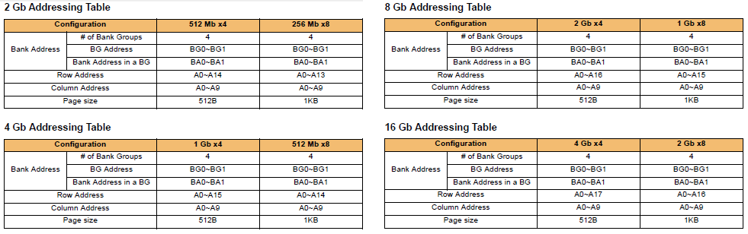

### Physical Address

Using the current maximum physical address space in 64 bit system architecture of 248 bytes or 256 TB, the physical address will be 48 bits. This will need to translate into a maximum of 32 bits of memory address.

### Memory Address

The memory address or address that is specific to the memory topology for DDR4 can range from 28 to 32 bits. This depends completely on the chosen topology of the manufacturer and the capacity of the DIMM as seen in the above tables.

### Address Translation